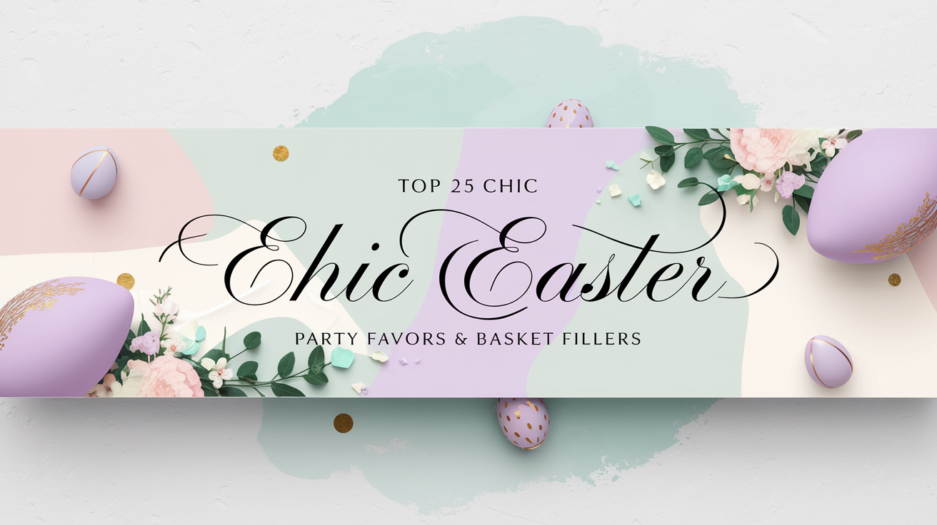

25 Chic Easter Favors & Basket Stuffers
- Gourmet Chocolate Eggs
- Miniature Champagne Bottles
- Pastel French Macarons
- Elegant Floral Candles
- Personalized Satin Sleep Masks
- Luxury Bath Bombs
- Mini Succulent Plants
- Embroidered Handkerchiefs
- Petite Lavender Sachets
- Mini Artisan Jams
- Silk Ribbon Hair Ties
- Crystal Wine Stoppers
- Monogrammed Easter Cookies
- Rose Gold Compact Mirrors
- Miniature Perfume Rollers
- Gold Foil Chocolates
- Small Vintage Frames
- Decorative Tea Infusers
- Organic Lip Balms
- Handcrafted Soap Bars
- Miniature Journals
- Floral Seed Packets
- Chic Keychain Charms
- Small Marble Coasters
- Elegant Bookmark Tassels

